**Resource Group**

## **What is a resource group**

A resource group is a container that holds related resources for an Azure solution. The resource group can include all the resources for the solution, or only those resources that you want to manage as a group. You decide how you want to allocate resources to resource groups based on what makes the most sense for your organization. Generally, add resources that share the same lifecycle to the same resource group so you can easily deploy, update, and delete them as a group.

The resource group stores metadata about the resources. Therefore, when you specify a location for the resource group, you are specifying where that metadata is stored. For compliance reasons, you may need to ensure that your data is stored in a particular region.

**Create Resource group**

1. Open azure portal search for resource groups.

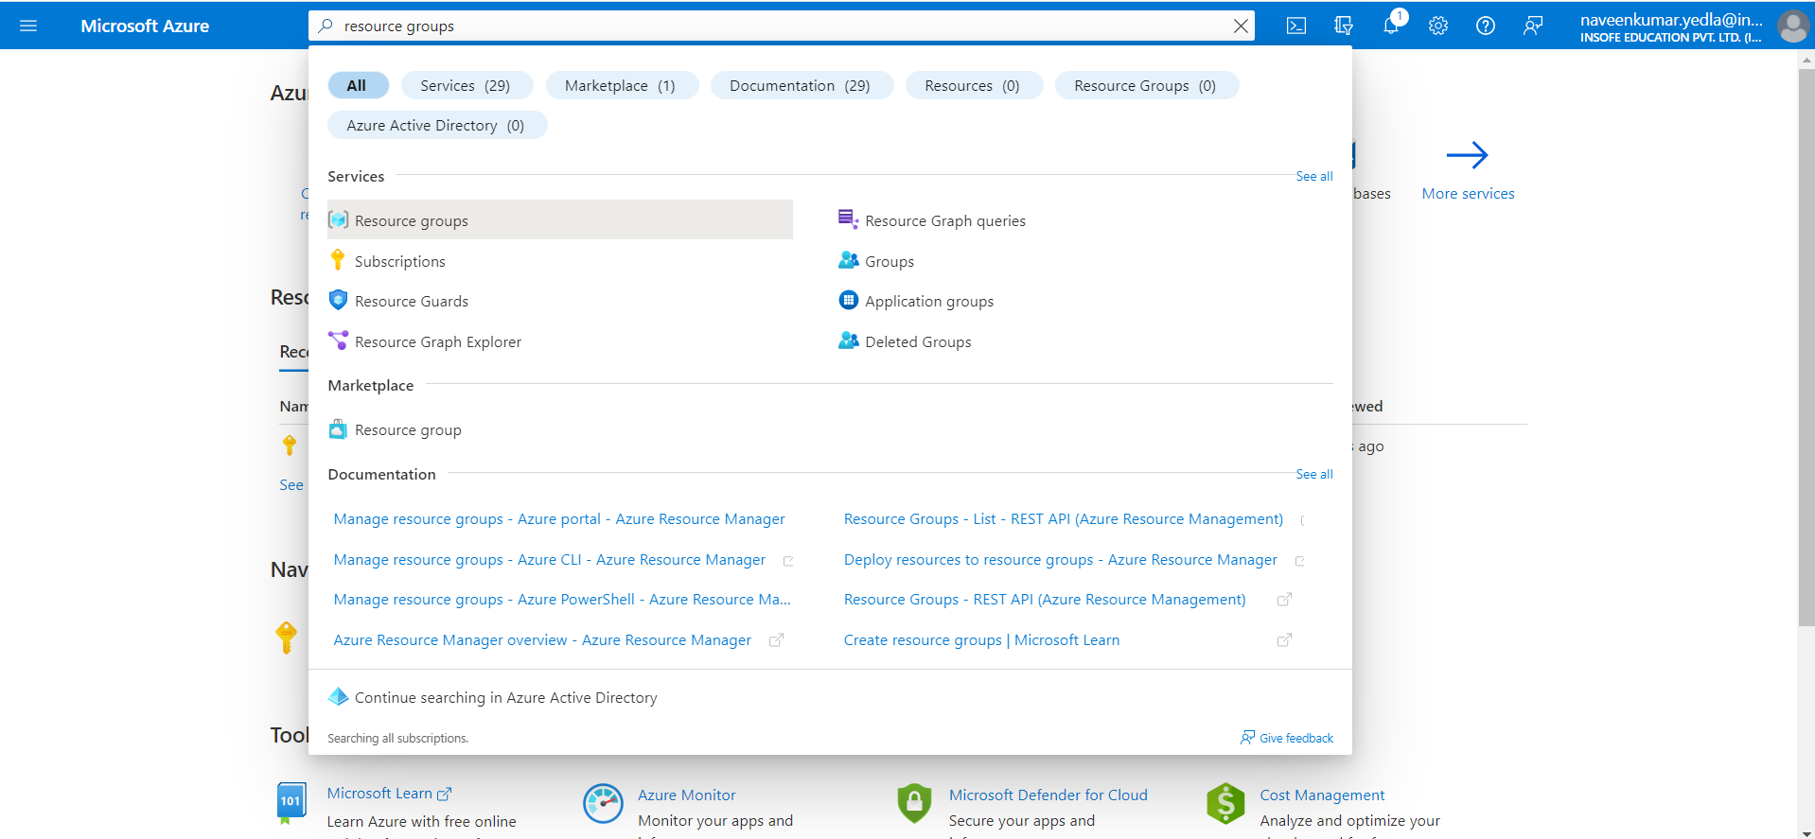

1. Click on Create.

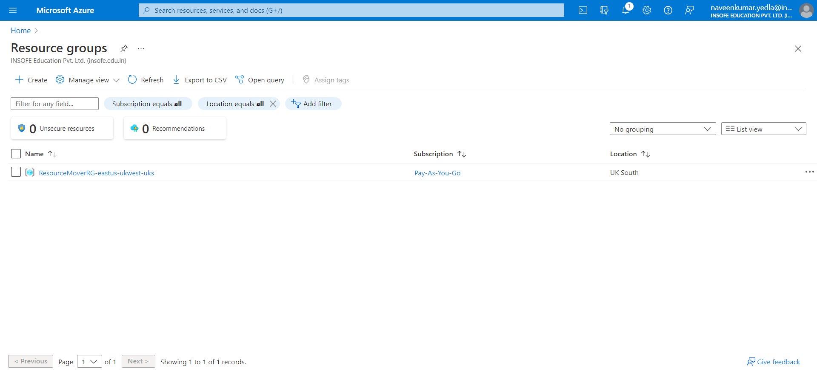

1. Subscription: Select your Azure subscription.
2. Resource group: Enter a new resource group name.
3. Region: Select an Azure location, such as East US.
4. Click on Review + create.

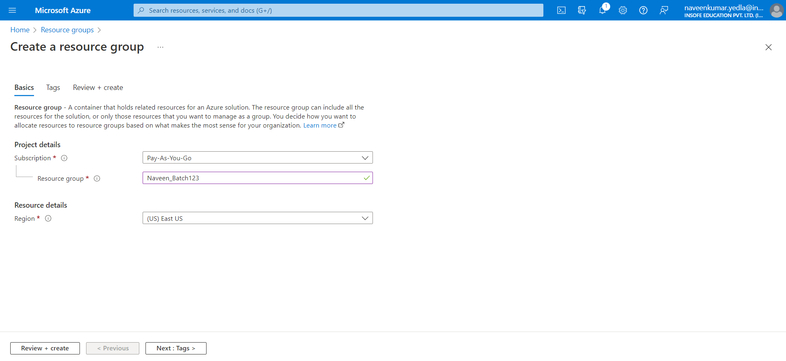

1. After validation passed click on create.

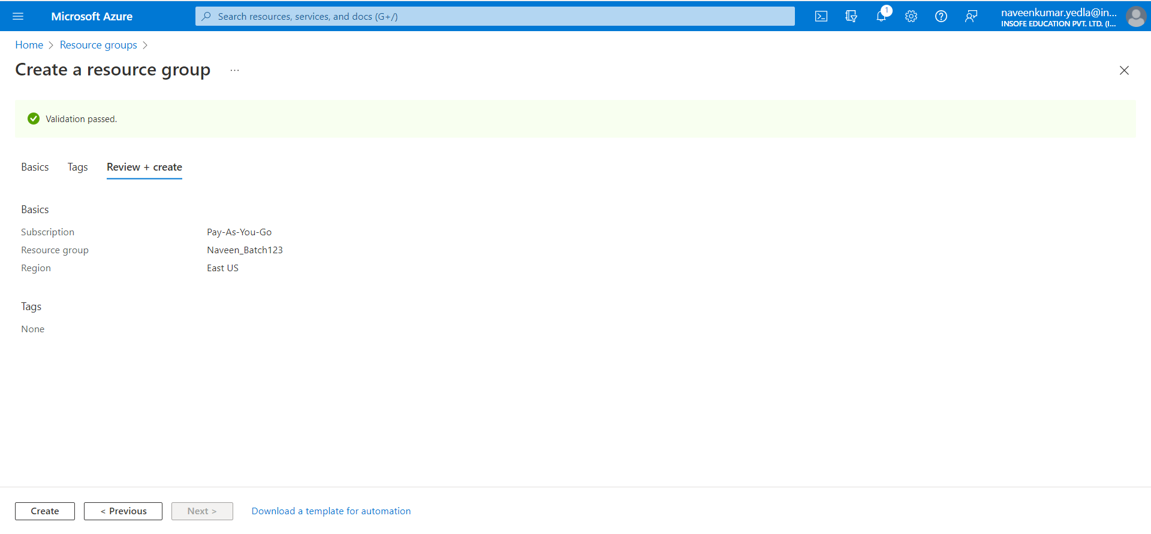

1. Click on notifications bar you can able to see the deployment status. It will take few seconds to create resource group.
2. Click on Go to resource group.

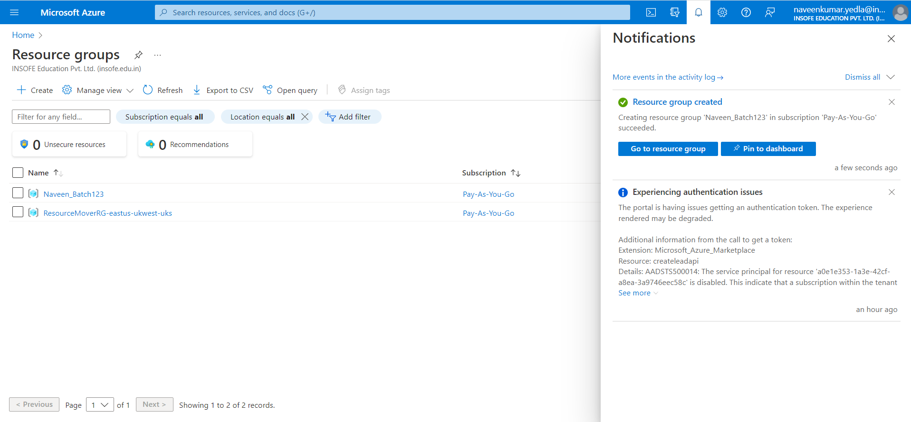

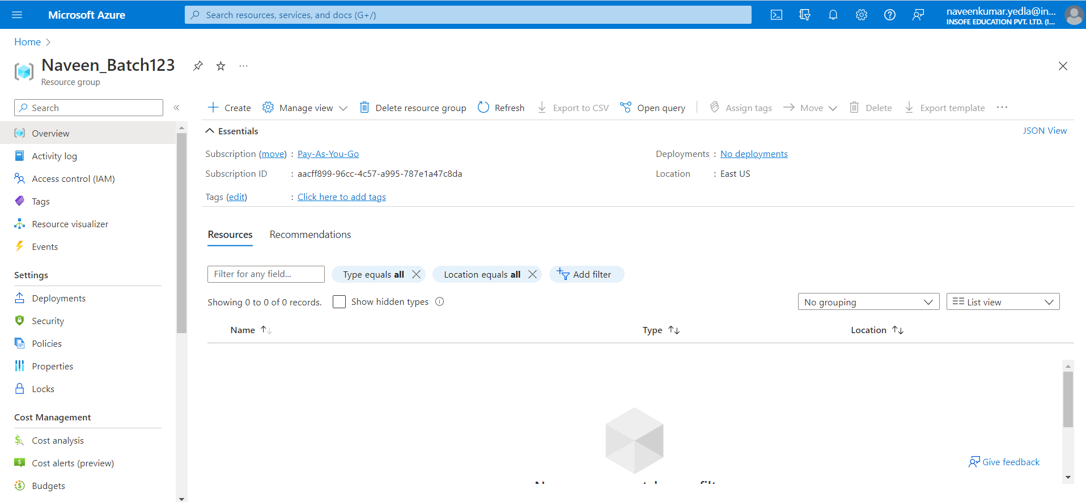

**Delete Resource Groups.**

When no longer needed, you can delete the resource groups.